1. Negation

image = imread('image.jpg');

image = rgb2gray(image);

figure(1);

imshow(image);

for i=1:size(image,1)

for j=1:size(image,2)

img1(i,j) = 255-image(i,j);

end;

end;

figure(2);

imshow(img1);

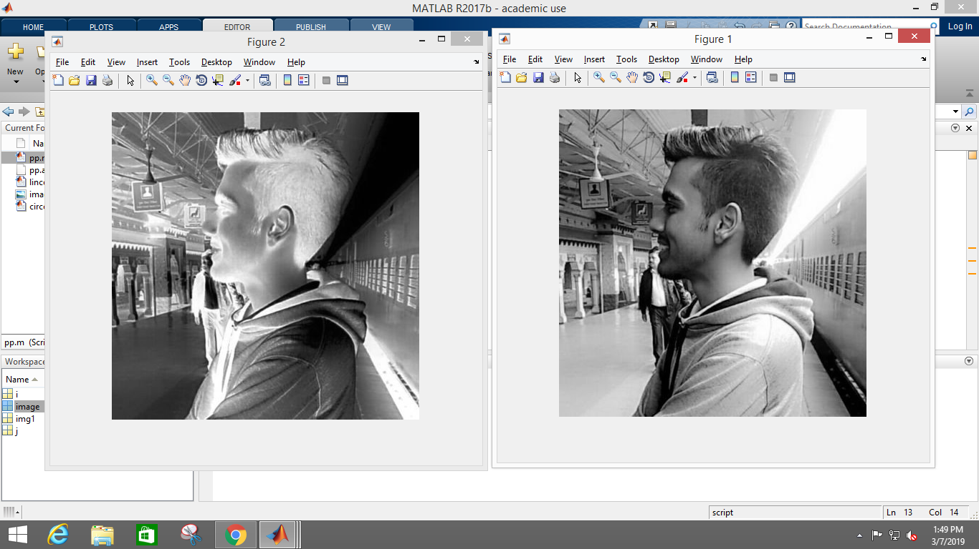

1. Thresholding

threshold = input('Value of threshold');

image = imread('image.jpg');

image = rgb2gray(image);

figure(1);

imshow(image);

for i=1:size(image,1)

for j=1:size(image,2)

if(image(i,j)<threshold)

img2(i,j)=0;

else

img2(i,j)=255;

end;

end;

end;

figure(2);

imshow(img2);

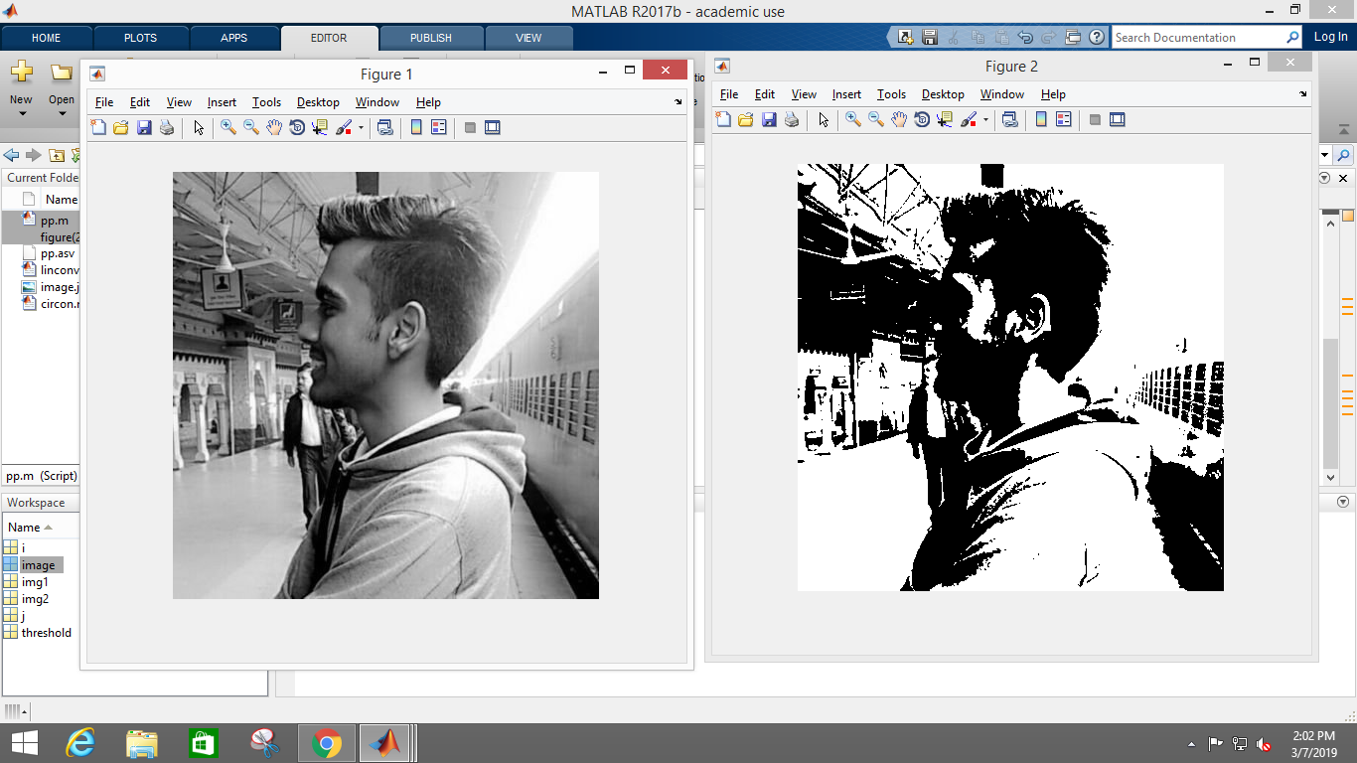

1. Grey scale with background

r1 = input('Enter r1: ');

r2 = input('Enter r2: ');

image1 = imread('image.jpg');

image = rgb2gray(image1);

figure(1);

imshow(image);

title('Original image');

for i=1:size(image,1)

for j=1:size(image,2)

if(image(i,j)>=r1 && image(i,j)<=r2)

image(i,j)=255;

end

end

end

figure(2);

imshow(image);

title('Grey level slicing with background');

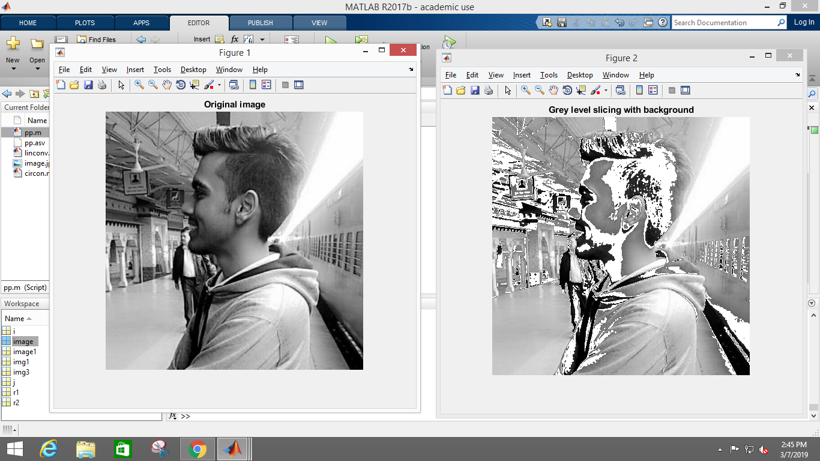

1. Grey scale without background

r1 = input('Enter r1: ');

r2 = input('Enter r2: ');

image = imread('image.jpg');

image = rgb2gray(image);

figure(1);

imshow(image);

for i=1:size(image,1)

for j=1:size(image,2)

if(image(i,j)>=r1 && image(i,j)<r2)

img3(i,j)=255;

else

img3(i,j)=0;

end

end

end

figure(2);

imshow(img3);

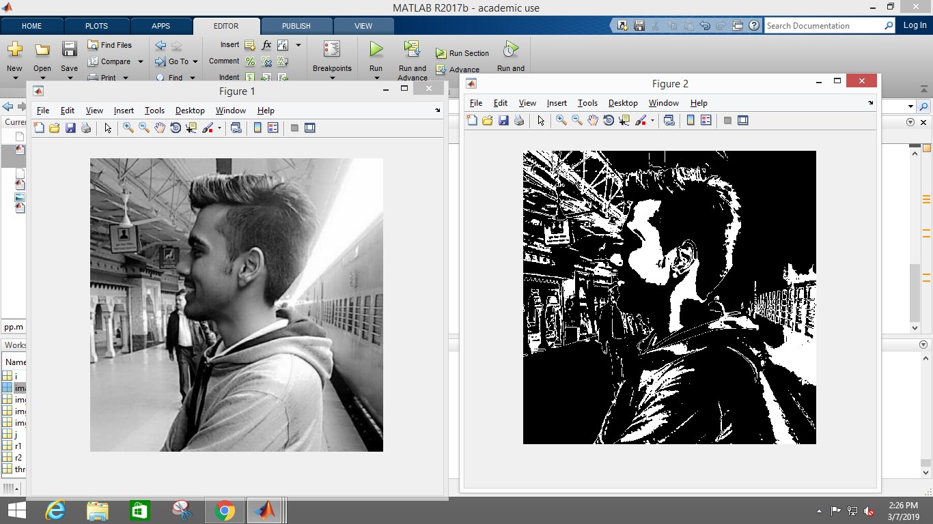

1. Bit plane slicing

image1 = imread('image.jpg');

image = rgb2gray(image1);

figure(1);

imshow(image);

title('Original image');

b1=[];

b2=[];

b3=[];

b4=[];

b5=[];

b6=[];

b7=[];

b8=[];

for i=1:size(image,1)

for j=1:size(image,2)

t=de2bi(image(i,j),8);

b1(i,j)=t(1,1);

b2(i,j)=t(1,2);

b3(i,j)=t(1,3);

b4(i,j)=t(1,4);

b5(i,j)=t(1,5);

b6(i,j)=t(1,6);

b7(i,j)=t(1,7);

b8(i,j)=t(1,8);

end

end

figure(2);

subplot(3,3,1);

imshow(b1);

subplot(3,3,2);

imshow(b2);

subplot(3,3,3);

imshow(b3);

subplot(3,3,4);

imshow(b4);

subplot(3,3,5);

imshow(b5);

subplot(3,3,6);

imshow(b6);

subplot(3,3,7);

imshow(b7);

subplot(3,3,8);

imshow(b8);

